**ITA 04 – Analytical Class work – Day 1**

1. **Let us take the example of a summer camp in which 20 students assign certain jobs that they performed to earn money to raise funds for a school picnic. However, different students earned different amounts of money. Based on the information given below, determine the skewness in the income distribution among the students during the summer camp**

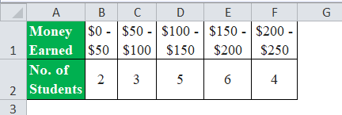

Mean: Standard Deviation Skewness

Mean of Distribution Formula Standard Deviation Formula Skewness Formula

1. Find out Kurtosis type for given data Y=**26, 12, 16, 56, 112, 24**

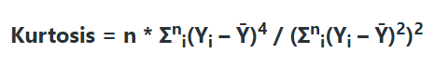

1. the mean score of students in a class is greater than 70 with a [standard deviation](https://www.simplilearn.com/tutorials/statistics-tutorial/what-is-normal-distribution) of 10. If a sample of 50 students was selected with a mean score of 80, calculate the Z-value to check if there is enough evidence to support this claim at a 0.05 significance level. the critical value at alpha = 0.05 is 1.645.

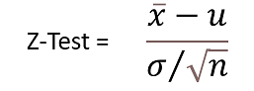

1. A teacher claims that his section's students will score higher than his colleague's section. The mean score is 22.1 for 60 students belonging to his section with a standard deviation of 4.8. For his colleague's section, the mean score is 18.8 for 40 students and the standard deviation is 8.1. Test his claim at α = 0.05
2. A store wants to improve its sales. The previous sales data shows that the average sale of 30 salesmen was $40 per sale. After some training, the current data showed an average sale of $60 per transaction. If the standard deviation given is $20, find the t-value. Did training improve the sales?  the alpha value of 0.05, the critical value is 1.711

One-Sample T-Test - Formula

1. Suppose you want to determine if the height of women with fathers 6 feet or taller in our class is significantly different from the average height of women in the US population. According to Wikipedia, the average height of women in the US is 64 inches, but the website does not provide standard deviations. The heights of the 34 women with fathers 6 feet or taller in our class has a mean of 66.62 and a standard deviation of 2.663 inches. Is this mean significantly different from 64 inches? Use an α value of 0.05
2. Find the correlation coefficient, r, between x and y for the data in the dosage example.

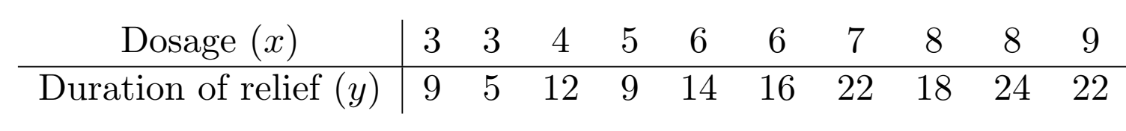

Student Practice:

1. The population of all verbal GRE scores are known to have a standard deviation of 8.5. The UW Psychology department hopes to receive applicants with a verbal GRE scores over 210. This year, the mean verbal GRE scores for the 42 applicants was 212.79. Using a value of α = 0.05 is this new mean significantly greater than the desired mean of 210?
2. Suppose you start up a company that has developed a drug that is supposed to increase IQ. You know that the standard deviation of IQ in the general population is 15. You test your drug on 36 patients and obtain a mean IQ of 97.65. Using an alpha value of 0.05, is this IQ significantly different than the population mean of 100?
3. Suppose the life expectancy of Seattleites has a population that is normally distributed with a standard deviation of 1. You go out and sample 45 Seattleites from this population and obtain a mean life expectancy of 88.51 and a standard deviation of 1.0815. Using an alpha value of α = 0.05, is this observed mean significantly different than an expected life expectancy of 89?.
4. Tomorrow you sample the evil of 50 eggs from a population and obtain a mean evil of 95.43 and a standard deviation of 5.165 . Using an alpha value of α = 0.01, is this observed mean significantly different than an expected evil of 93? What is the effect size? Is the effect size small, medium or large?
5. Find the correlation coefficient between *x* and *y* for the following two data sets:

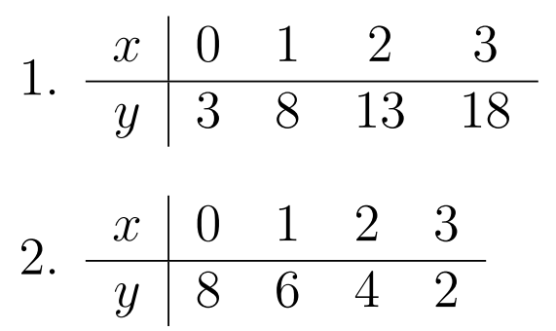

Ref: <https://www.wallstreetmojo.com/t-test/>

https://courses.washington.edu/psy315/tutorials/